**Lesson Plan**

**Weird Deep-Sea Animal**

Animal and Habitat Biodiversity

Kimi Kato, Toro Park School, Salinas, CA

Claudia Paul, University of Alaska Fairbanks

**Objective:** In this lesson, students create a unique ocean animal to discover how adaptations help them survive in their habitat. First, students think about animals that live thousands of meters below the sea surface and some of their adaptions. For a second activity, students roll a dice to randomly assign their animal an adaptation challenge, then build their animal using recycled materials. Students then share their unique animal to gain an understanding of how their animal adapts to its environment.

**Materials and Resources for this Lesson**

Included in this box:

* Student booklet (one copy for each student)
* Building materials (you may wish to add more of your own materials)
* Five cold glue guns and glue sticks
* Ten cards illustrating 3 Vocabulary Words (adaptation, camouflage, habitat)
* Activity Poster of Pelagic Zones with Animals that stick ot the Poster with Velco
* Book: Big Al by Andrew Clements and Yoshi (included in box) – More about making friends and fitting in, but elements of camouflage (Grades K-2)
* Book: Weird Sea Creatures by Erich Hoyt – Images of about 50 Deep-Sea Animals with supporting paragraphs (Grades 2-5).
* Material List
* 4 Dice
* Prompt Card: For Student’s Show & Tell Presentation

Not included but needed for this lesson.

* Scissors, pencils, colored pencils or crayons.
* Teacher – Locate and view 2 YouTube Videos (10 minutes each) – Links below

**Prep Instructions**

* Hand out copies of the student booklet.
* Prepare and View links: YouTube videos-MBARI (Monterey Bay Aquarium Research Institute)

# **Octopus Odyssey | 4K ROV Highlights**

<https://youtu.be/hhH42NS8ig4?si=ya9sqFNbqeB_18-F>

1. **MBARI's Top 10 deep-sea animals**

<https://youtu.be/80OG2BGrmyA?si=4lEoNvBkLNDie53j>

**Vocabulary (Cards included)**

**Adaptation** - a change or the process of change by which an animal becomes better suited to its environment.

**Habitat -** the natural home or environment of an animal, plant, or other [organism](https://www.google.com/search?sca_esv=f716cdc2862777a3&sca_upv=1&q=organism&si=ACC90nx67Z8g0WkBmnrPB4IqtqGvfp15jMqzitI2F2w0P9XLQmLS38cmChOF7vIG0aVAPOhksINdFTpmNV_axsyYhlMUFD18Nzpo7RPPflfU7a65CJ1GdmU%3D&expnd=1&sa=X&ved=2ahUKEwiTg4ecosKGAxWcAzQIHfURFjUQyecJegQIDxAO).

**Camouflage –** hide or disguise.

**Day 1-EXPLORATION (30-40 mins.)**

**View Video #1**- **2:54 Octopus Odyssey (and /or MBARI's Top 10 deep-sea animals)**

**Say:** You will now watch a video of real deep-sea creatures. As you watch, pay close attention to the animals’ bodies, coloring, features, or structures. Where do you notice camouflage? Adaptations? What do you observe about the habitat?

**Say:** What did you notice? What did you wonder?

Show the video (s).

* Activity Poster of Pelagic Zones with Animals **-** printed diagram, organisms that have Velcro and stick on the diagram, and

Explain how most people can explore a few feet into the intertidal. We are thinking about animals that live thousands of meters below the surface.

**Epipelagic Zone (Sunlight Zone)**:

This is the top layer, extending from the surface down to about 200 meters (656 feet). This zone gets plenty of sunlight, which allows plants like phytoplankton to grow. Many animals, such as tuna and sharks, sea turtles, coral reef animals, seals, whales, and dolphins, live here because there is lots of food.

**Countershading**: Many fish have dark backs and light bellies to blend in with the water when viewed from above or below.

**Streamlined bodies**: Fish like tuna have fusiform (torpedo-shaped) bodies for efficient swimming.

**Schooling behavior**: Small fish form large schools for protection against predators.

**Visual adaptations**: Well-developed eyes for hunting in the sunlit waters.

**Twilight Zone (Mesopelagic Zone)**

This zone is darker because less sunlight reaches here. This layer ranges from about 200 meters to 1,000 meters (656–3,280 feet) deep. Some sunlight gets in, but not enough for plants to grow. Animals in the twilight zone often have **large eyes** to help them see in the dim light, and many of them can make their own light, called **bioluminescence**, to attract prey or scare off predators. **Vertical migration**: Some animals move up to feed at night and descend during the day.

**Red coloration**: A red organism will appear black and therefore be hard to spot at depth.

**Bathypelagic Zone (Midnight Zone)**:

This dark zone extends from 1,000 meters to about 4,000 meters (13,123 feet). No sunlight reaches this depth, and the water is very cold. Creatures here, like giant squids, have special adaptations to survive in the dark and high pressure. Because it’s so dark, animals here often have very small or no eyes at all. Many rely on **bioluminescence** to find food or mates. Some fish have big mouths and sharp teeth to catch whatever food drifts by, as meals can be rare in the deep ocean.

**Reduced body size**: Many deep-sea fish are smaller to conserve energy.

**Lack of swim bladders**: Most deep-sea fish lack swim bladders due to high pressure.

**Squishy bodies:** many animals living in this zone have squishy, transparent bodies.

**Specialized sensory organs**: Some fish have organs that can detect both red and ordinary light.

**Abyss (Abyssopelagic Zone)**

The abyss is incredibly deep, stretching from 4,000 meters to 6,000 meters (13,123–19,685 feet). It’s very cold (2oC), and the pressure is crushing. Despite this, some animals still live here (e.g., deep-sea jellyfish, basket stars, sea cucumbers).

**Adaptations:** Animals in the abyss are slow-moving to save energy in such a harsh environment. They have bodies that can withstand the intense pressure, they don’t need sunlight because they get their food from dead plants and animals sinking from above.

**Trenches (Hadalpelagic Zone)**

This is the deepest part of the ocean, found in places like the Mariana Trench. This zone extends from 6,000 meters (19,685 feet) to more than 10,000 meters (32,808 feet). It’s the most extreme place in the ocean! Amphipods and Sea pigs make this zone their home.

**Pressure resistance**: Animals have adaptations to withstand extreme pressure.

**Low metabolic rates**: To conserve energy in a food-scarce environment.

**Lack of pigmentation**: Many deep-sea creatures are pale or transparent.

**Hand out animal cards** and have Students place their animal onto the appropriate pelagic zone on the poster. Discuss different features.

* **Review vocabulary** (cards included). How do these words fit with the animals on the Activity Poster of Pelagic Zones?

**DAY 2-HANDS-ON ACTIVITY-*BUILDING DAY (45 mins.)**

PREPARATION:

Place all materials for animal creation on a large table or counter area. Gather building materials from the box and lay out on a large surface area, a table or counter. This is where students will collect items they need to build. Add any additional materials you may have such as paper towel rolls, straws, craft sticks, small paper cups, foam shapes, etc.

Display *Vocabulary Chart Materials List and Animal Photos popup*

Set up a “Glue Gun Station.” A place where these can be plugged in and students can work. This may be some small tables or a few desks pushed together. Glue guns need about 10 minutes to heat up.

Before you begin, let students know they will use these materials to create a weird deep-sea animal.

* **Read aloud** story - Big Al *(Appropriate for grades 1-3) or Grades* Weird Sea Creatures *(4-6 Grades)*

**Say,**

*“As I read the story, watch for camouflage. See if you can spot any adaptations.”*

You may wish to pause as you read and ask,

“Do you see any camouflage?” or “What adaptations do you notice?” or “What do you notice about the habitat?”

When done ask:

What did you notice? What did you wonder? How is this related to the **three vocabulary** words.

**Sketch Animal**

* Materials needed - Student booklets, dice, pencils, and colored pencils or crayons

Let students know they will create a model of their weird animal. Before they begin constructing their animal, review the materials (materials list chart) available for students to use for construction. This will help students visualize how they want to create their animal.

Next, each student rolls a die and circles the corresponding challenge.

*Have a sample booklet and die ready to review before handing them out to students.*

**Say**: Now it is your turn to create a weird ocean animal. Before you begin creating your animal, you will need to first sketch what you think it will look like. First, you will roll a die and circle the matching challenge you will need to include when creating your animal. (Review the challenges.)

Have each student take a turn rolling a die, then circling their corresponding challenge in their booklet. On the front of the booklet, students take 5-10 minutes to draw and label and if time permits, color their animal.

Review. Remind students of materials available for animal creations, “Show and Tell” style.

* Different materials have different properties
* Flowy, stiff, pliable, textured…..

Ask students to think about their animal sketch and begin to envision the types of materials they may need.

* Will your animal have sharp teeth? Spines? Taste bad? Poisonous?
* What will your animal need to protect itself?

Have students begin to make a list of materials they plan to use in their booklet.

Remind students that after their animal is created, they will share and others will try to guess what challenge was rolled. Excuse students to gather materials and begin creating.

Create: Allow 30-40 minutes for students to make their animal.

*Partner Option-Some students may elect to work with a partner. If this is the case, remind students that they create only one 3-D animal together. They must decide whose animal they want to make and how. They must also agree on who will get to take it home when they are done.

**DAY 3-WRAP-UP (30-45 mins.)**

Students finish animals and share their weird animal’s features. Others guess which adaptation challenge they rolled.

CULMINATION-SHOW AND TELL

Decide if you want to post the following sentence starters for students to use when they share. This supports students who may benefit from a visual prompt. (laminated card in kit)

* My weird animal moves by….
* It does/does not have eyes because….
* My animal protects itself by ….
* It eats by…
* Can you guess my challenge?

[Show and Tell](https://docs.google.com/document/d/1Usaov2vq3fMnUTkqvjw55whHps16NefRIX8suCpuAEc/edit?usp=sharing)

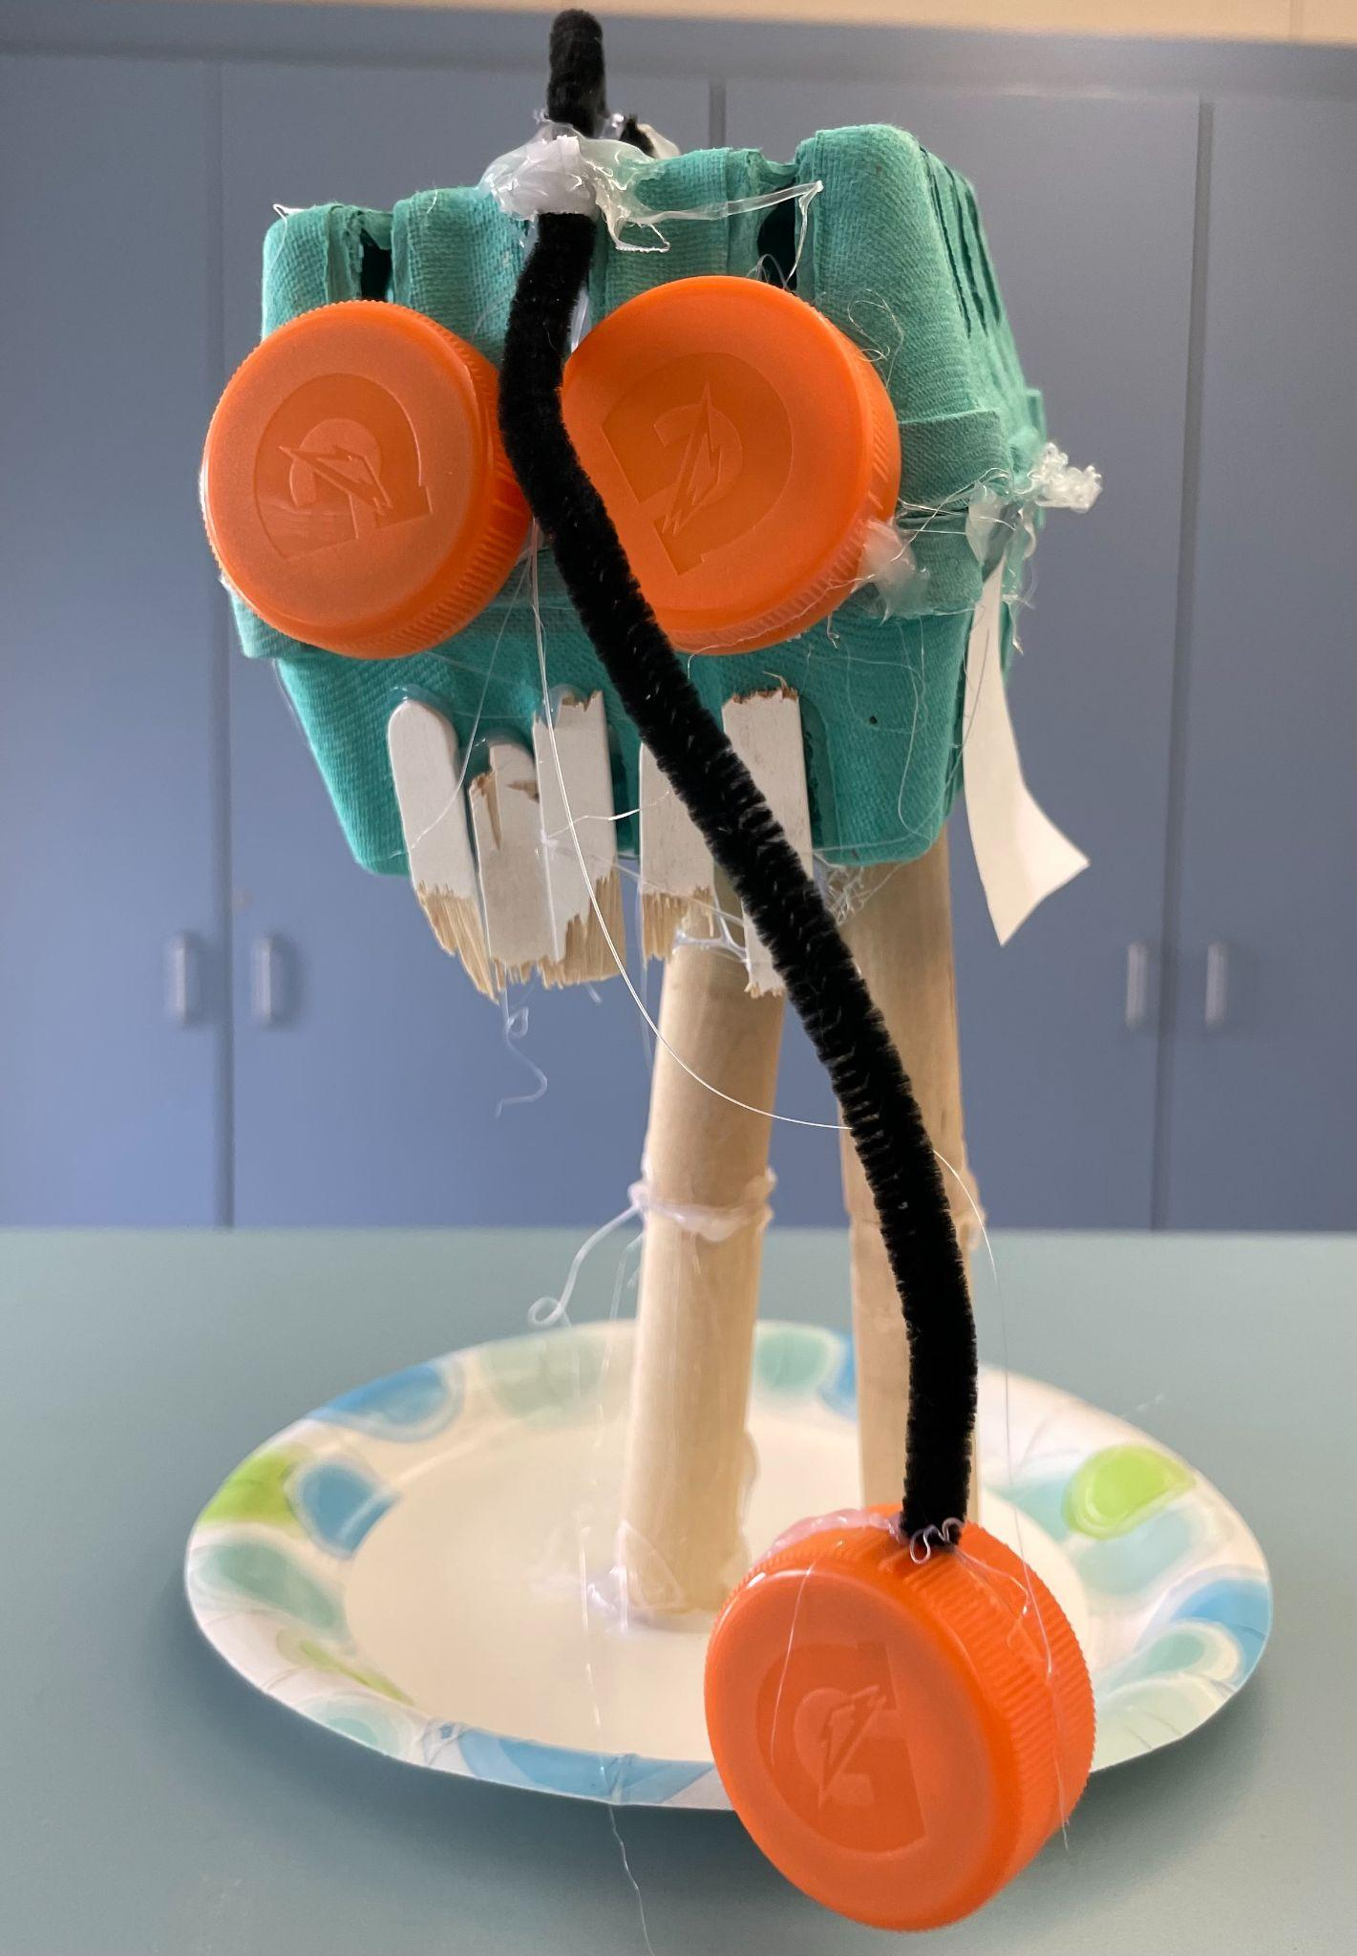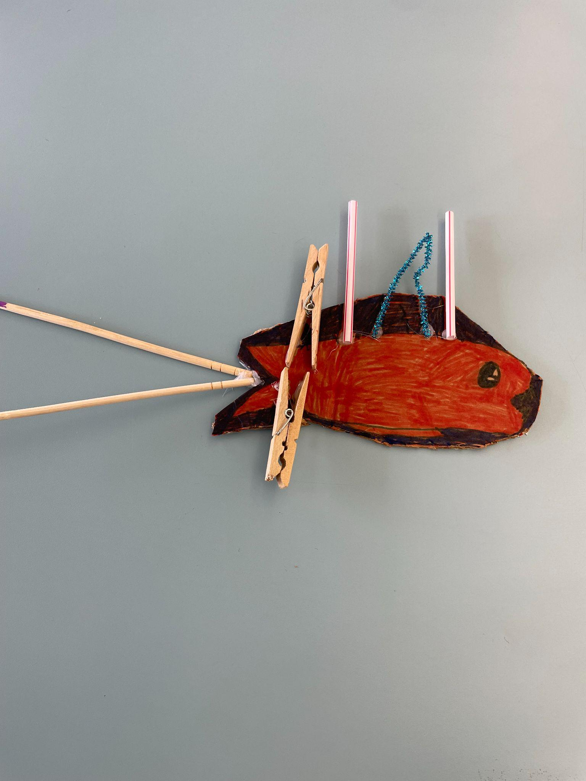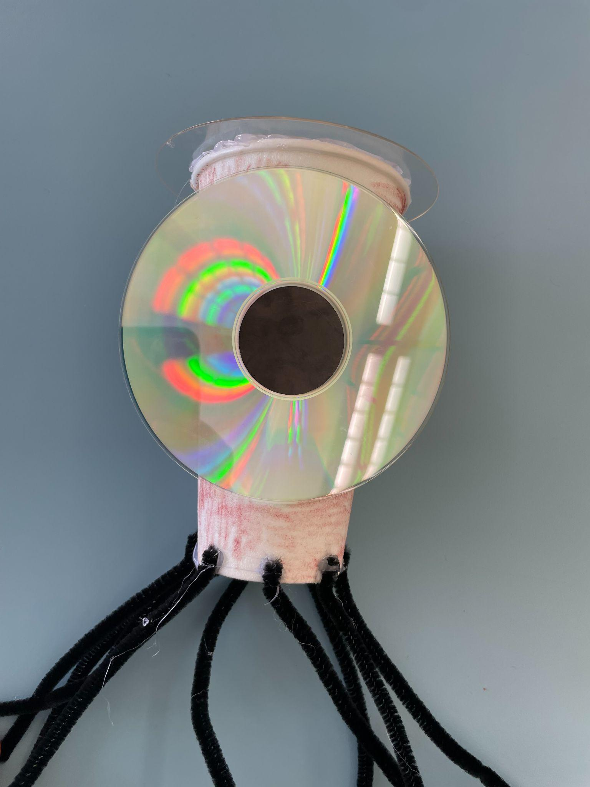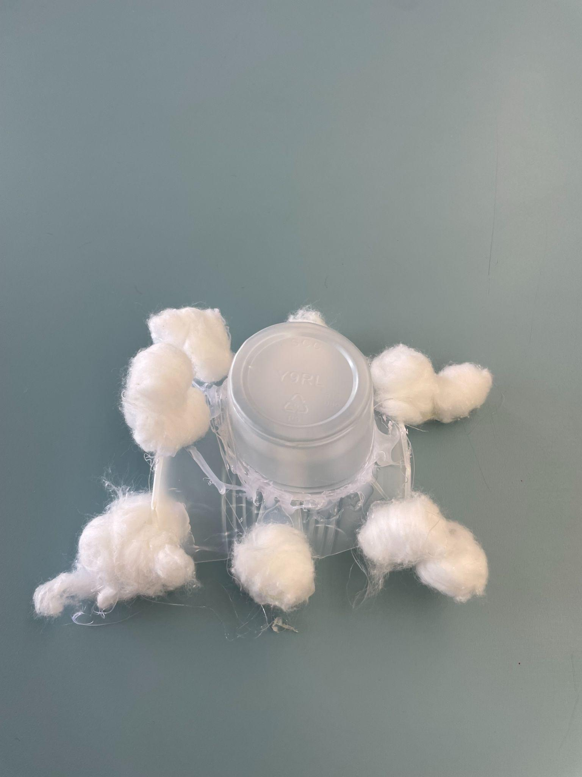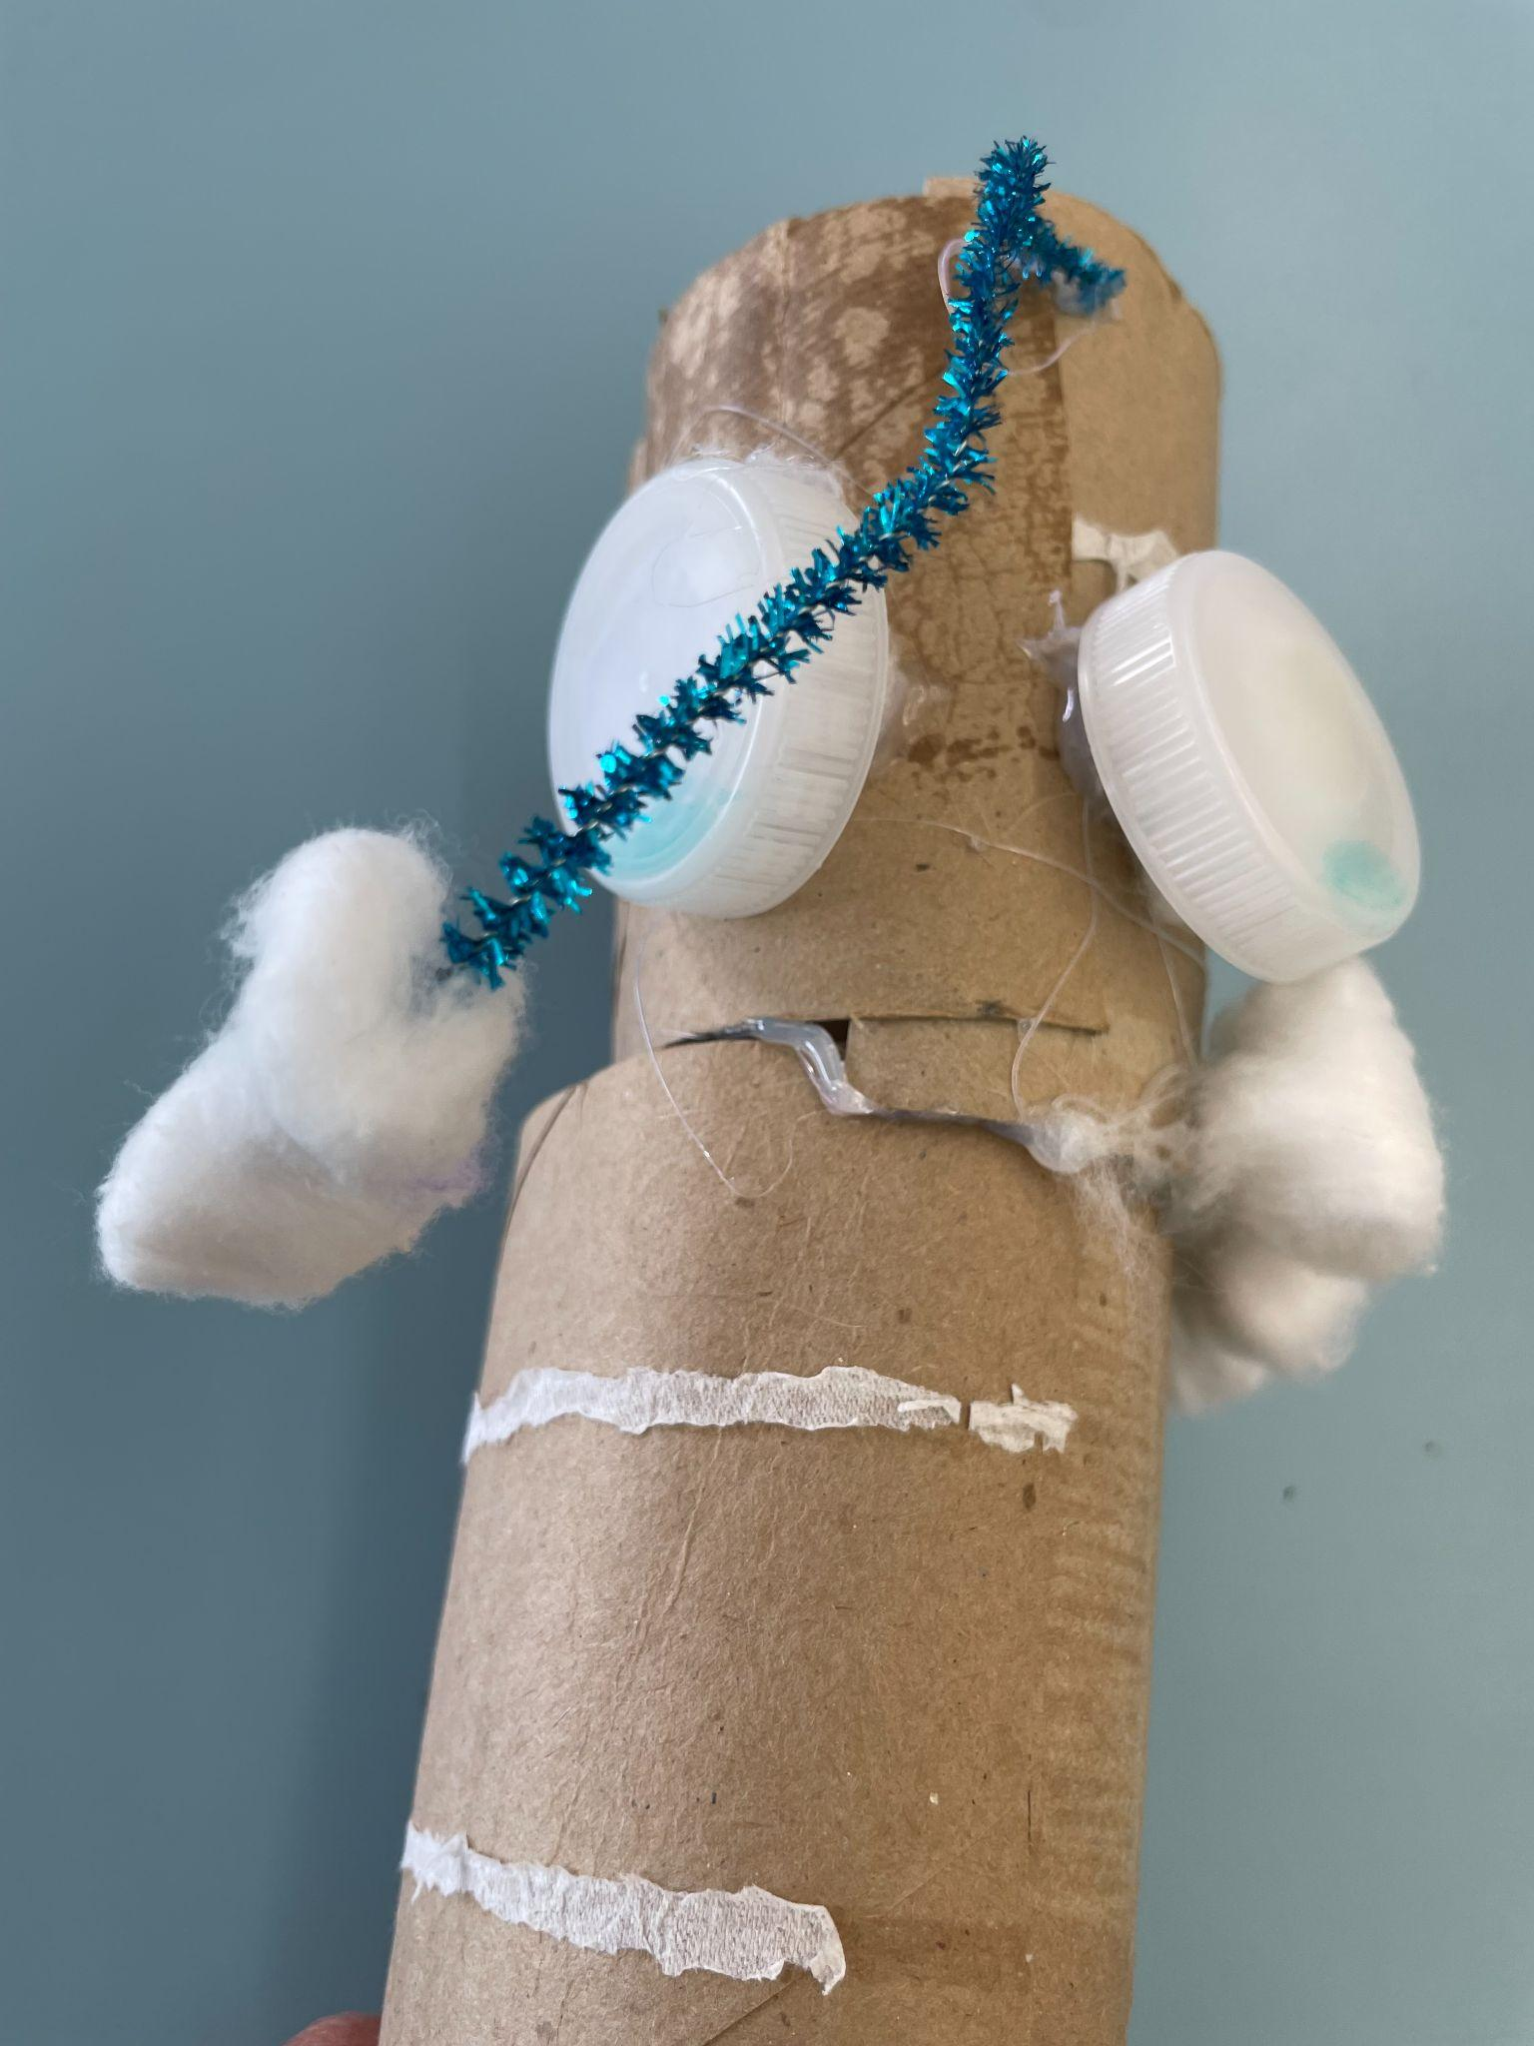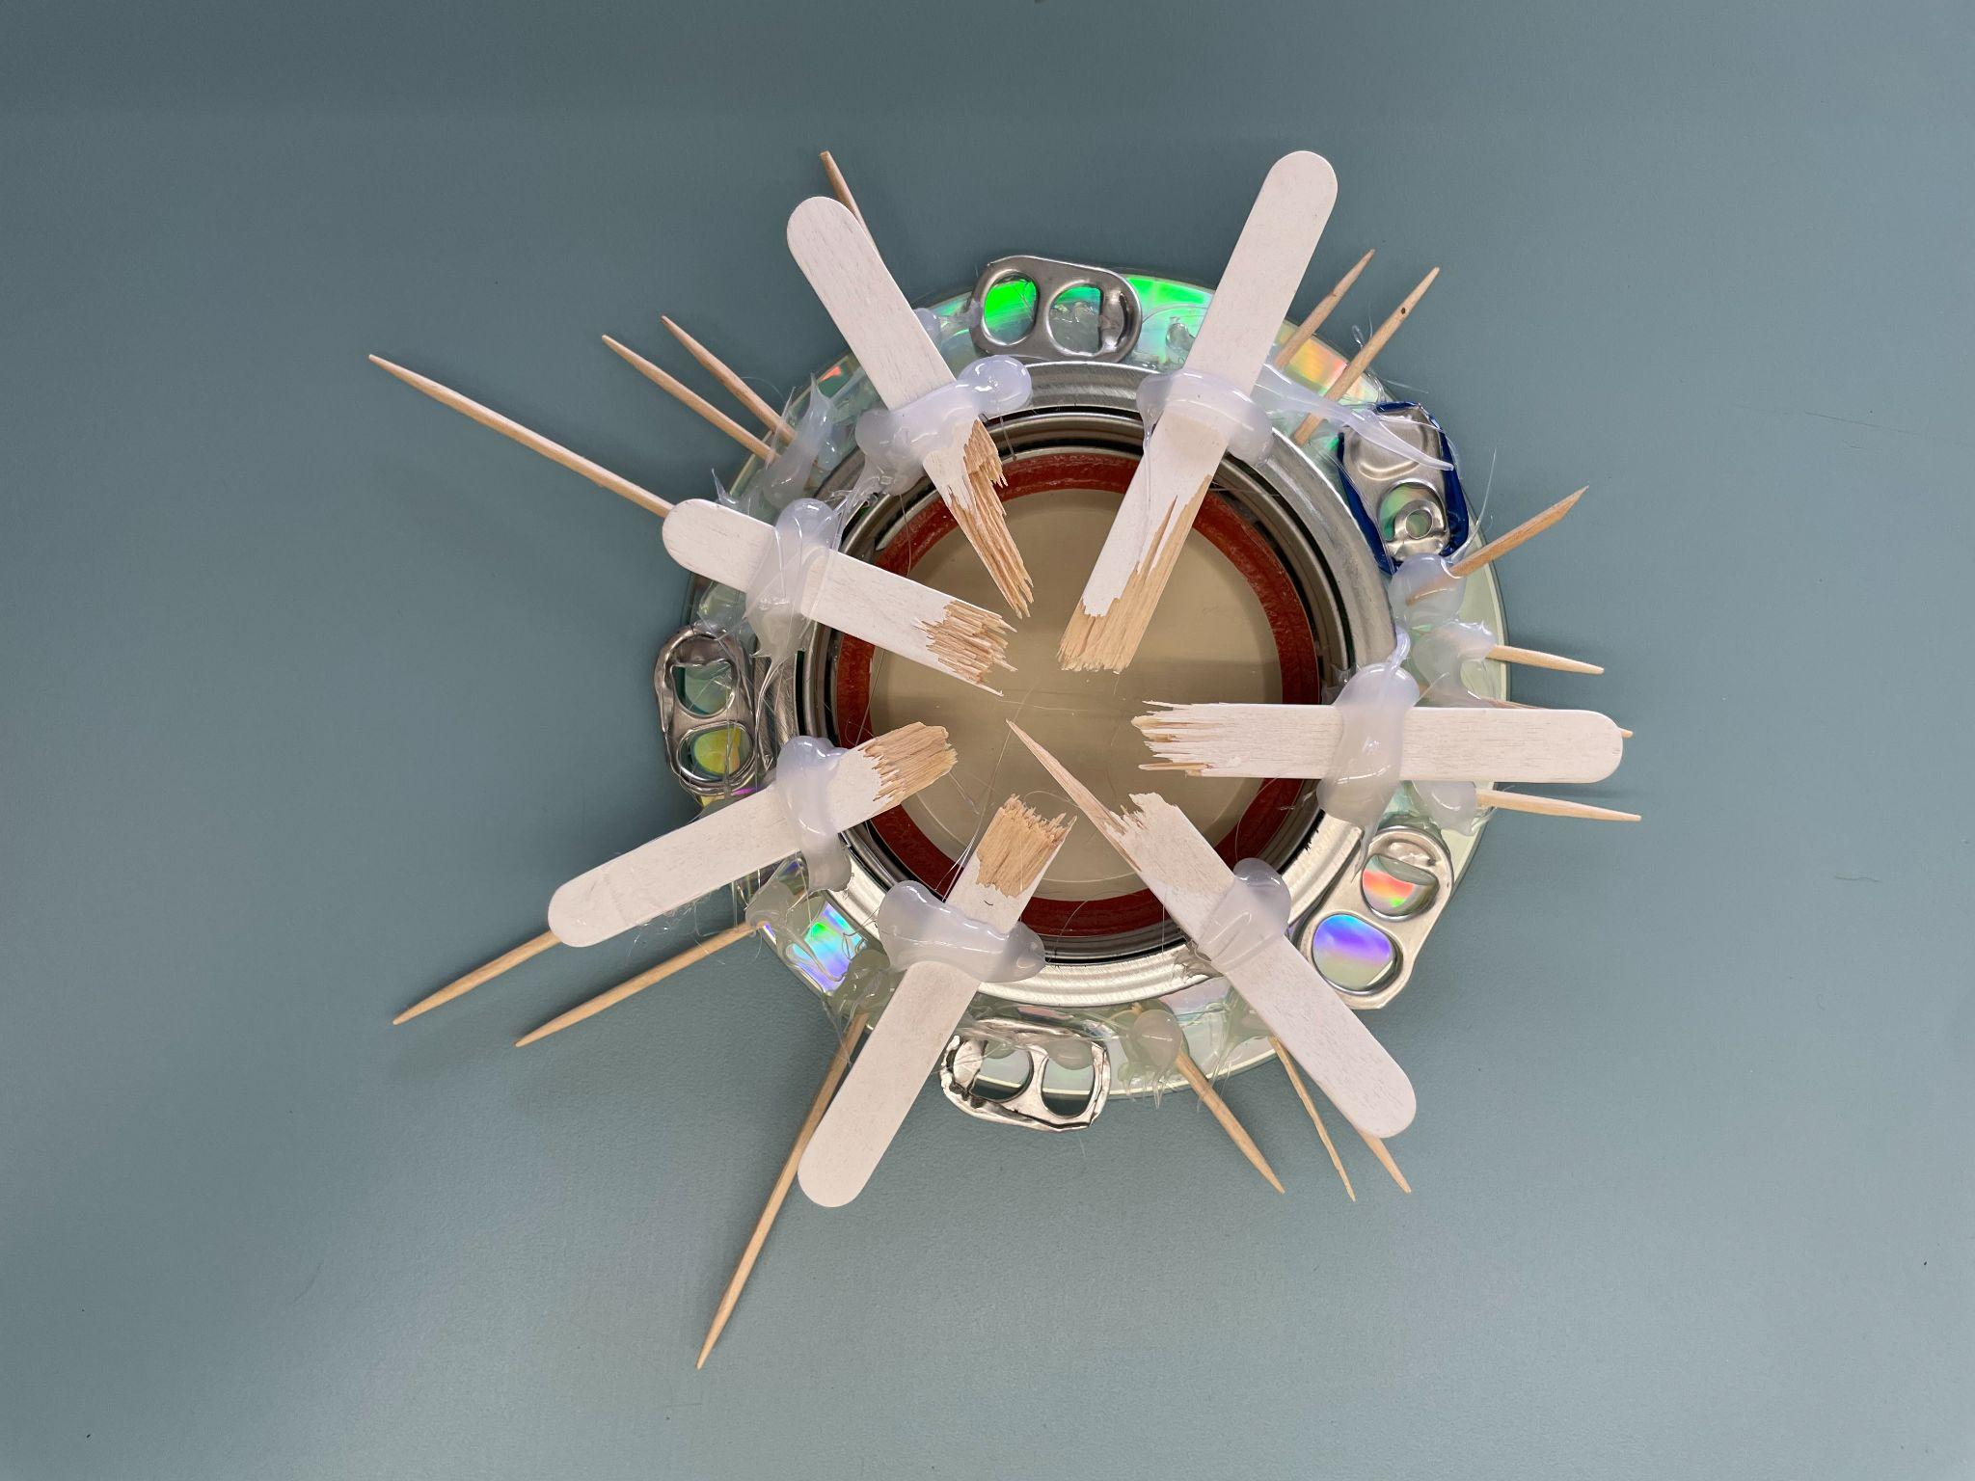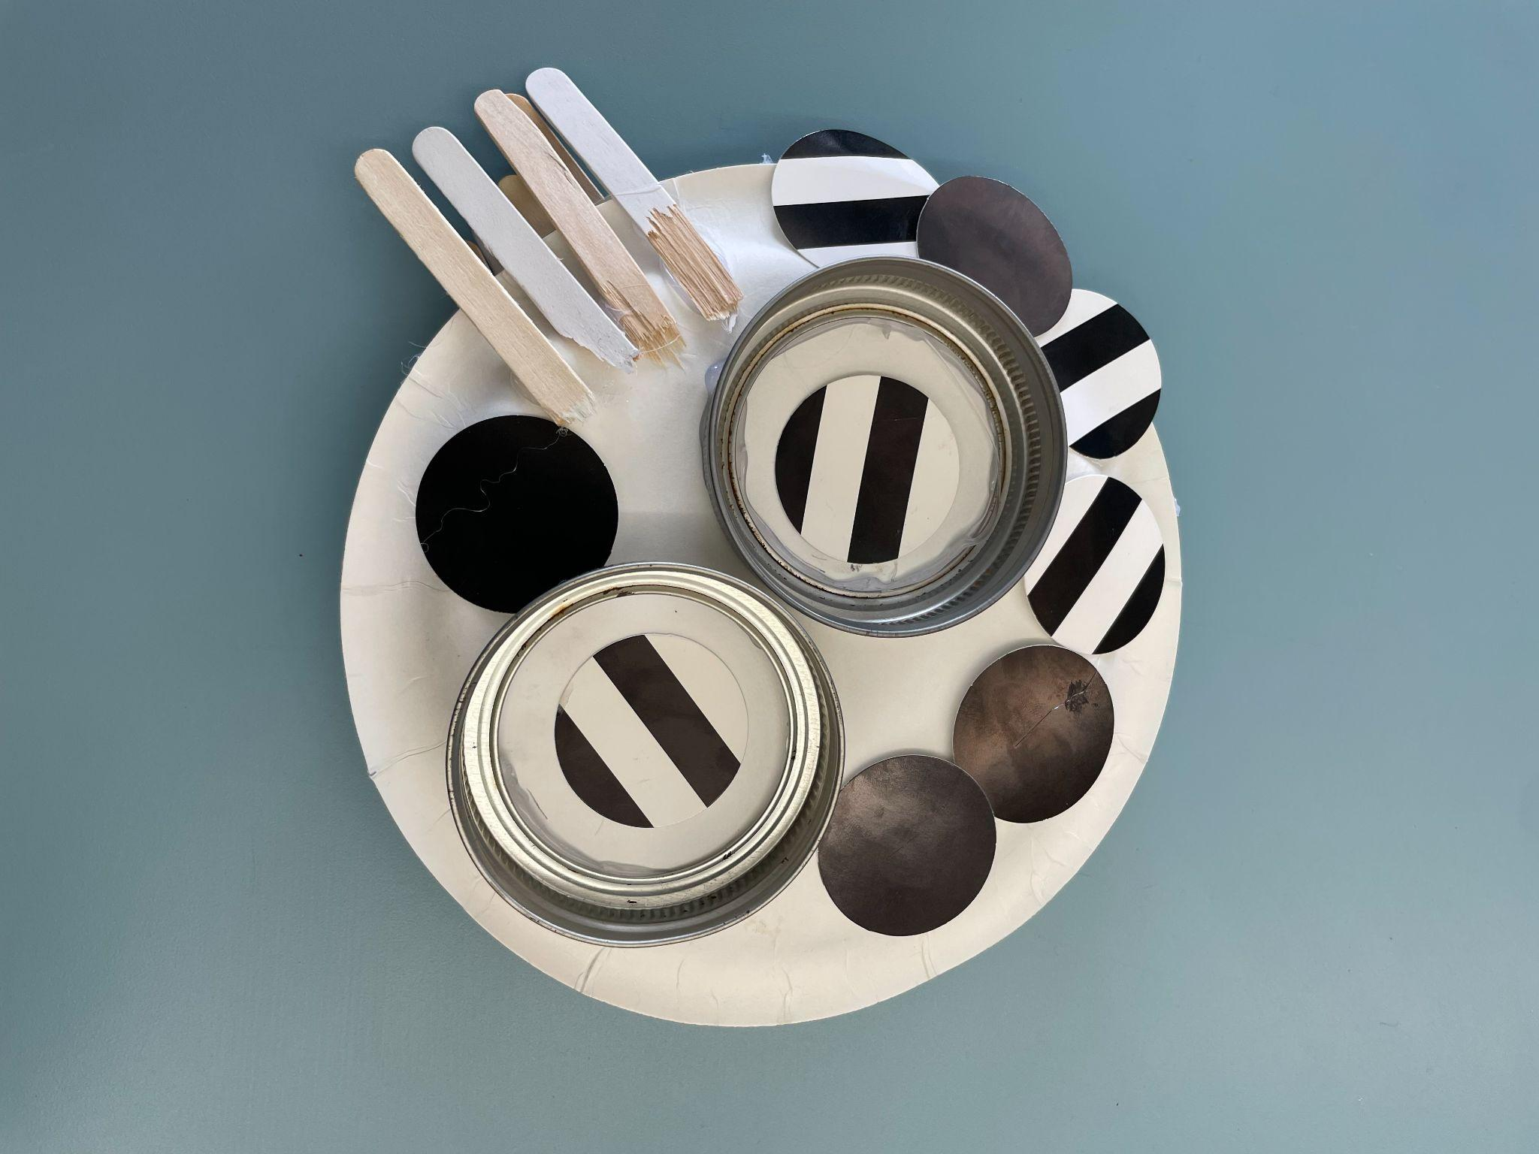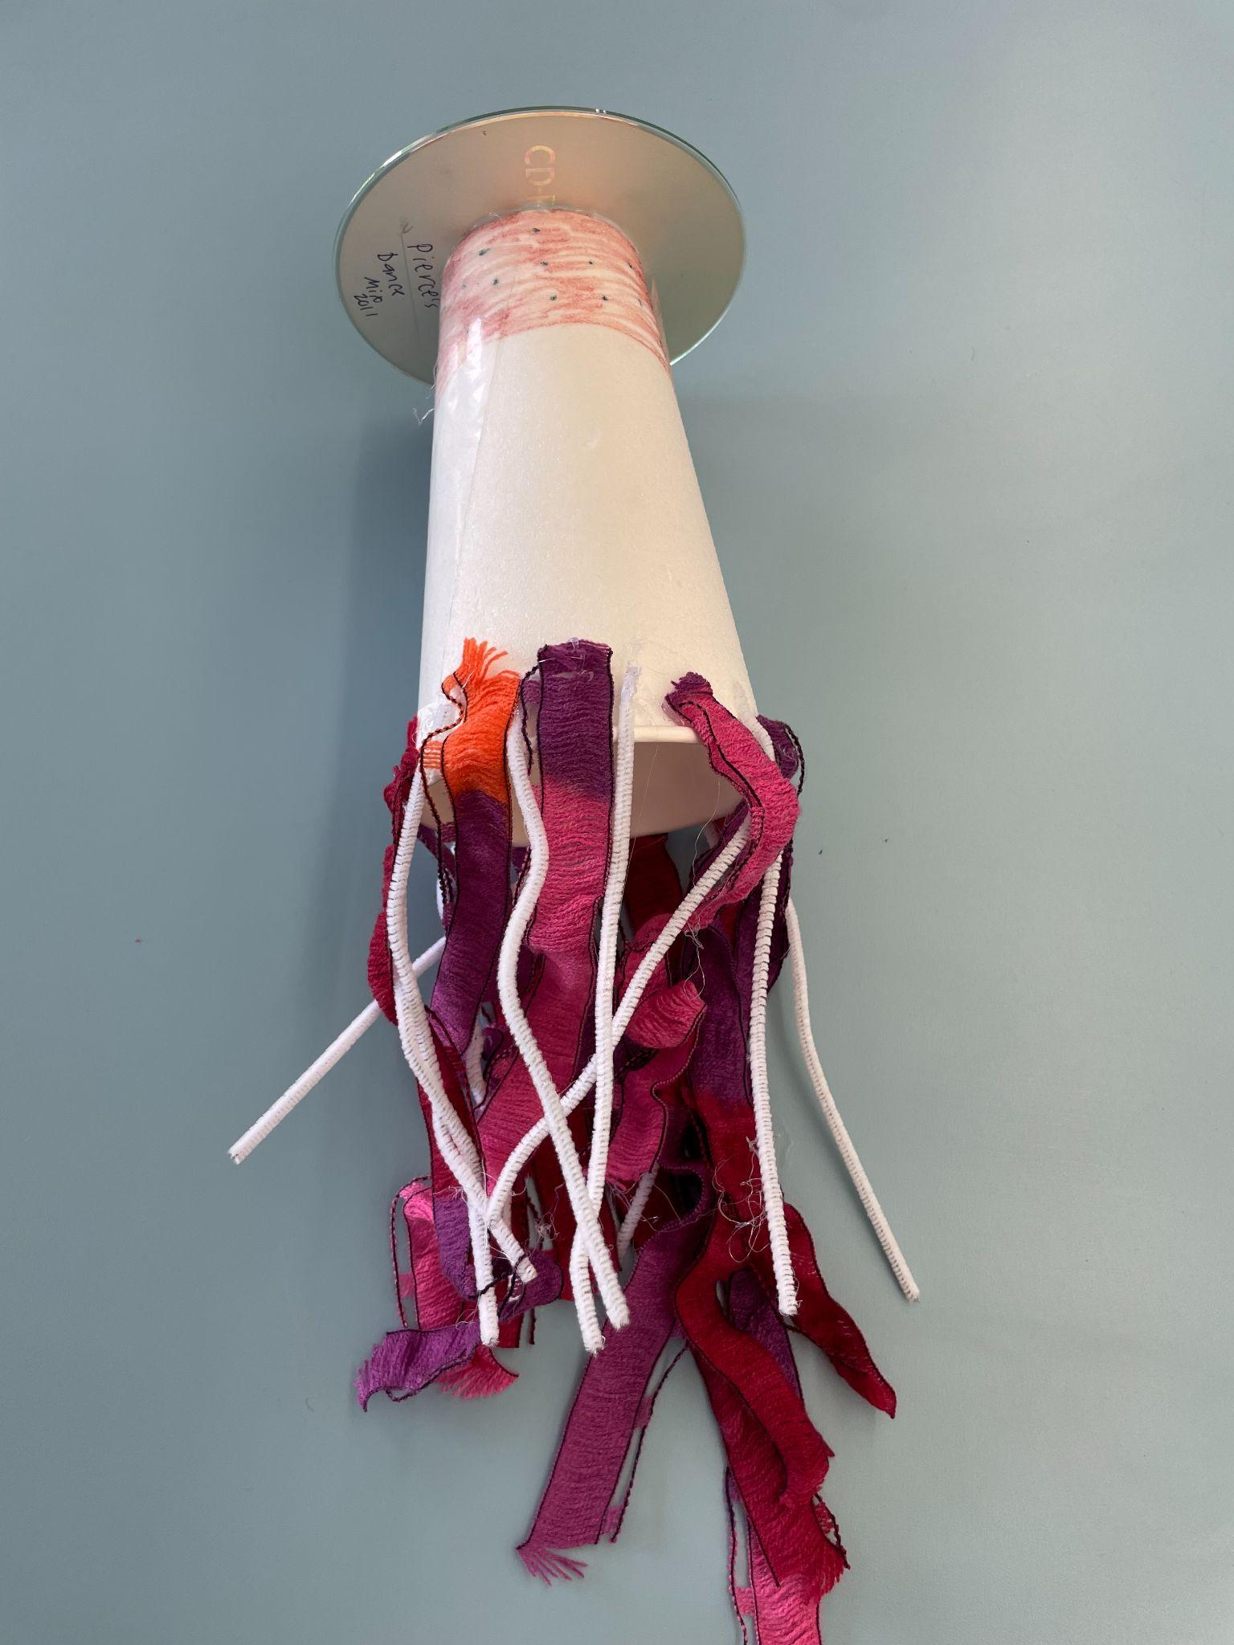

**Next Generation Science Standards**

**2-PS1-1** Plan and conduct an investigation to describe and classify different kinds of materials by their observable properties.

**K-2-ETS1-2:** Develop a simple sketch, drawing, or physical model to illustrate how the shape of an object helps it function as needed to solve a given problem.

**3-LS4-4:** Make a claim about the merit of a solution to a problem caused when the environment changes and the types of plants and animals that live there may change.* [Clarification Statement: Examples of environmental changes could include changes in land characteristics, water distribution, temperature, food, and other organisms.] [Assessment Boundary: Assessment is limited to a single environmental change. Assessment does not include the greenhouse effect or climate change.]

**K-ESS3-1:** Use a model to represent the relationship between the needs of different plants and animals (including humans) and the places they live. [Clarification Statement: Examples of relationships could include that deer eat buds and leaves, therefore, they usually live in forested areas; and, grasses need sunlight so they often grow in meadows. Plants, animals, and their surroundings make up a system.]

**2-LS4-1:** Make observations of plants and animals to compare the diversity of life in different habitats. [Clarification Statement: Emphasis is on the diversity of living things in each of a variety of different habitats.] [Assessment Boundary: Assessment does not include specific animal and plant names in specific habitats.]

**3-LS4-3:**  Construct an argument with evidence that in a particular habitat some organisms can survive well, some survive less well, and some cannot survive at all. [Clarification Statement: Examples of evidence could include needs and characteristics of the organisms and habitats involved. The organisms and their habitat make up a system in which the parts depend on each other.]